E.G.S.PILLAY ENGINEERING COLLEGE, NAGAPATTINAM
DEPARTMENT OF ELECTRICAL AND ELECTRONICS ENGINEERING
ASSIGNMENT NO – II ANSWER KEY
Sub Code & Name : GE 6252–Basic Electrical & Electronics Engg. Max.Marks: 50
Year & Sem : I / II Sem
Name of the Staff : V.MOHAN / K.NANDAKUMAR/ S.SIVAMANI

QUESTION 1.1:
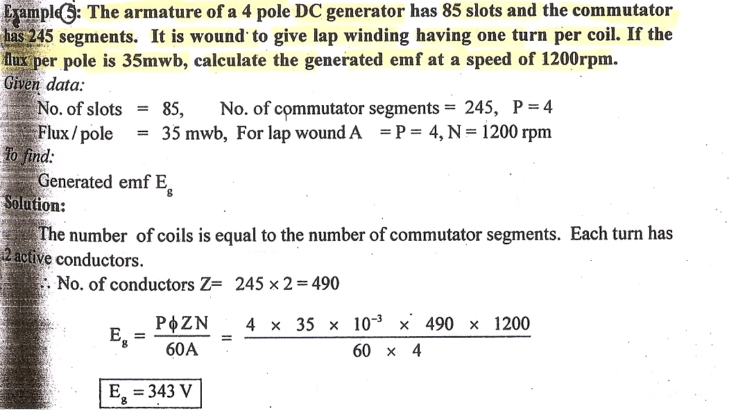
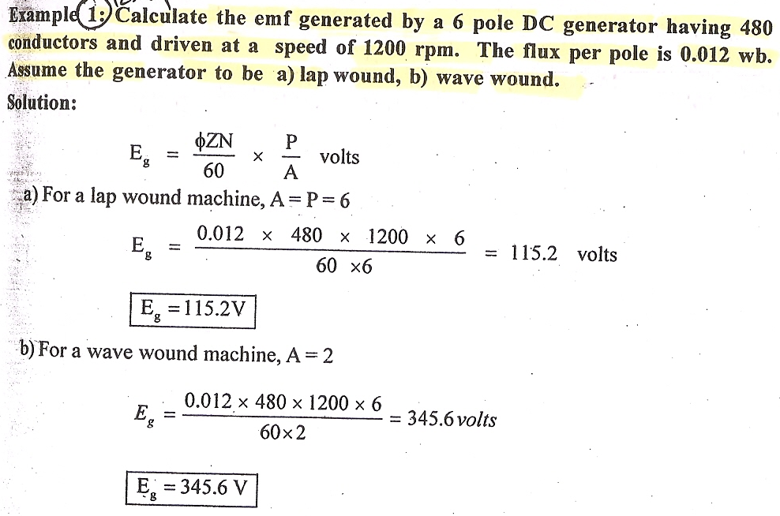
QUESTION 1.2:
QUESTION 2:

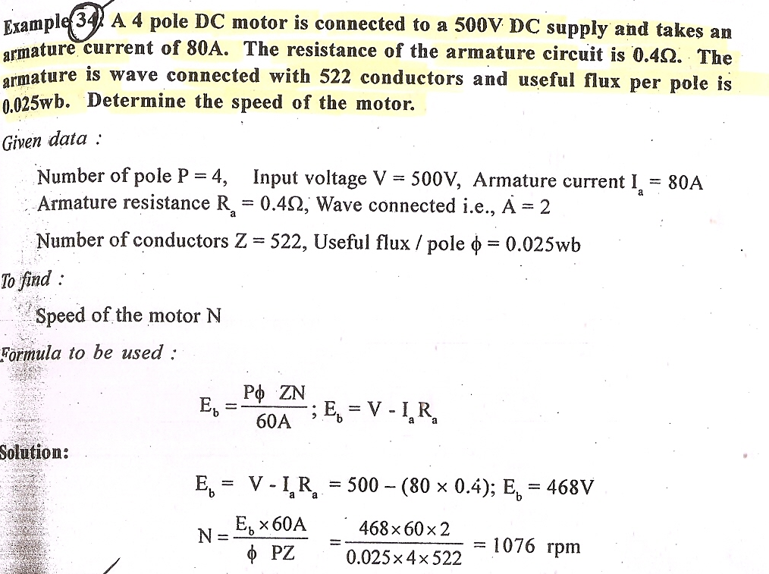

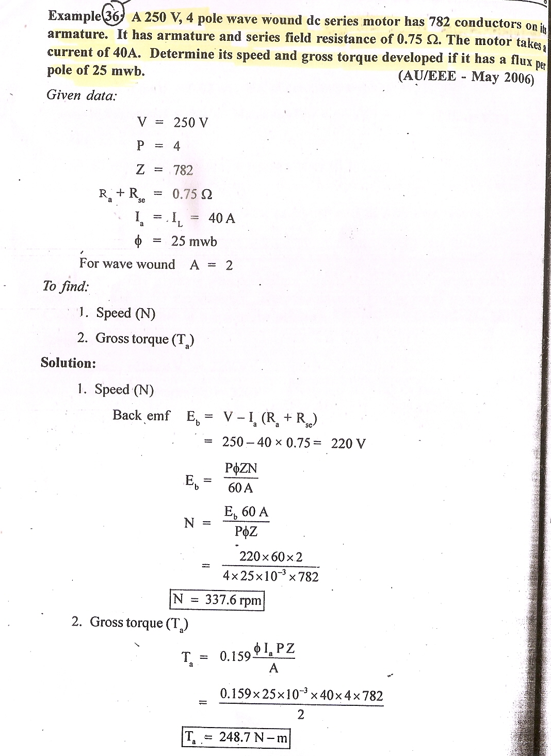
QUESTION 3:
QUESTION 4:
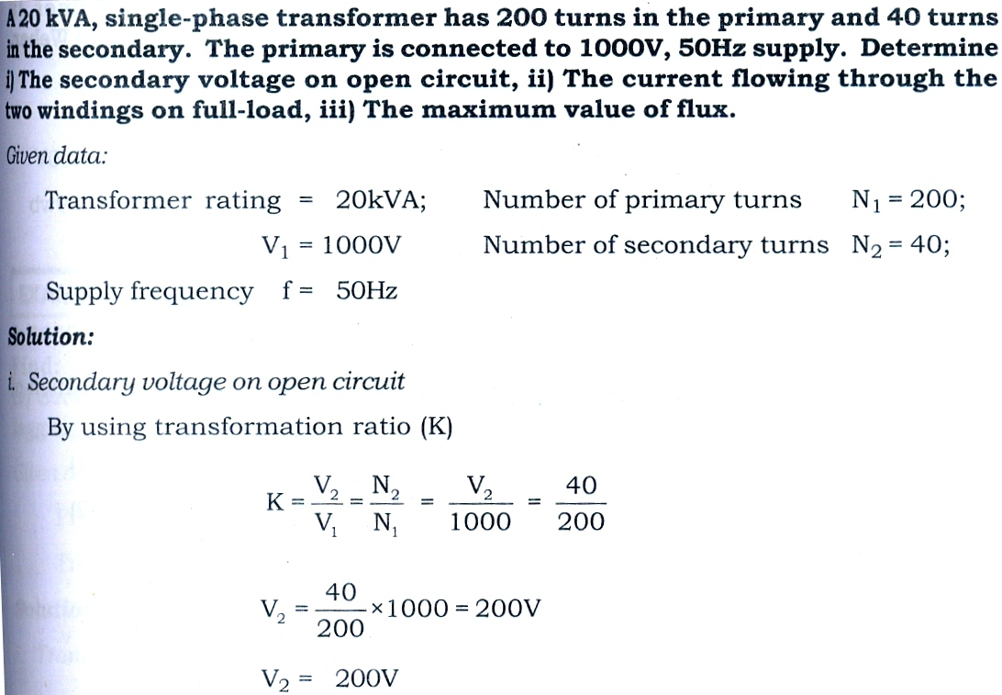
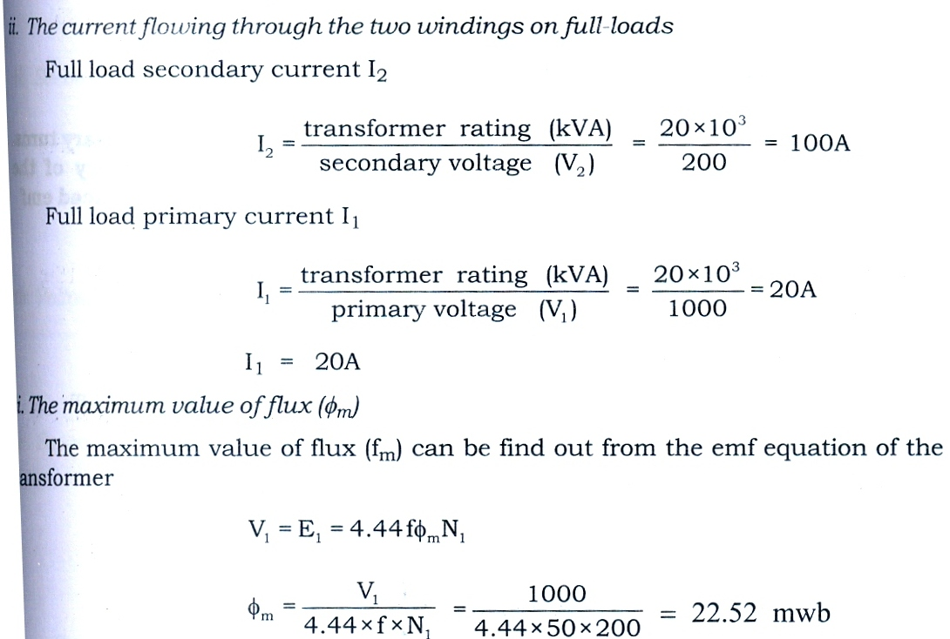
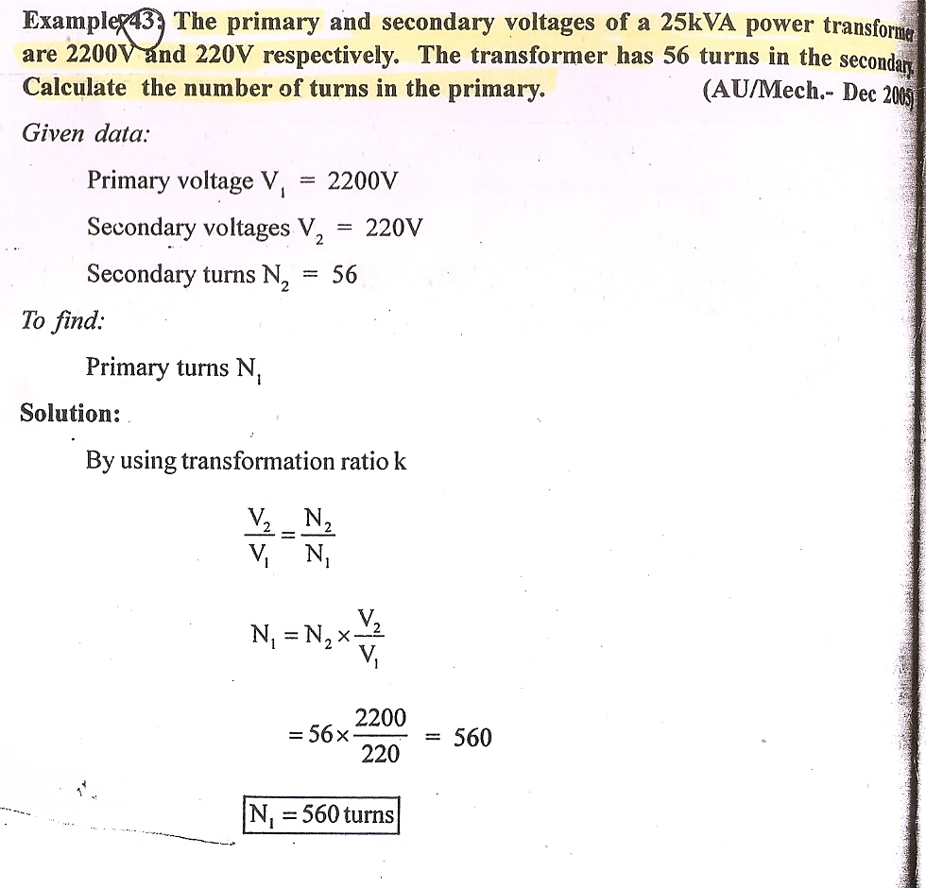
QUESTION 5.1:
QUESTION 5.2:
