E.G.S PILLAY ENGINEERING COLLEGE, NAGAPATTINAM
DEPARTMENT OF CIVIL AND MECHANICAL ENGINEERING
MODEL EXAM
Sub Code & Name : GE6252 & Basic Electrical and Electronics Engg. Date : 29-04-2014
Year & Semester : I & II Max.Marks : 100
Staff Name : V.Mohan, K.Nandakumar, S.Sivamani. Time : 1.30 PM to 4.30 PM

PART A 10 X 2 = 20 Marks
- State Ohms law and its limitations.
- Compare moving coil and moving iron instruments.
- Write the working principle of DC motor.
- Write the emf equation of a transformer.
- Give the applications of zener diode.
- What is early effect?
- Realize D latch using NAND gates.
- What is a decade counter?
- Define the term demodulation.
- Sketch the block diagram of basic communication system

PART-B 5 X 16 = 80 Marks
11. a) Use nodal analysis to determine the voltage across 5 ohm resistance and the current in the 12V source. (16)
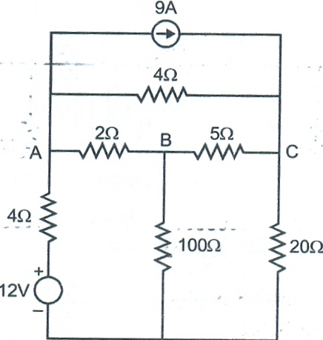
(OR)
11. b) i) With neat diagram, explain the construction and operation of an induction type energy meter (8)
ii) Explain the construction and operation of dynamometer type wattmeter with neat diagrams. (8)

12. a) Explain the operation of various types of single phase induction motors with neat diagrams. (16)
(OR)
12.b (i) Draw the circuit diagram and characteristics of the following three types of DC motors and write the relationships among the currents and voltages.1) Separately excited motor 2) Series motor 3) Shunt motor (8)
(ii) A DC motor connected to 460 V supply has an armature resistance of 0.15 ohms.Calculate a) the value of back emf when the armature current is 120 A b) The value of armature current when the back emf is 447 V (8)

13. a) Explain the V-I characteristics of PN junction diode and Zener diode. (16)
(OR)
13. b) Explain the working principle of half wave and full wave rectifiers with neat waveforms. (16)

14.a) i) Draw the logic diagram of a 4-bit binary ripple counter and explain its working. (8)
ii) Explain with neat sketch the working of binary ladder network for digital to analog conversion. (8)
(OR)
14.b) (i) Explain the operation of T and D flip flops with truth tables. (8)
(iii) Design a full adder by constructing the truth table and the output equations. (8)

15.a) (i) With necessary waveforms explain the basics of AM. List the merits and demerits of AM. (10)
(ii) Write a detailed note on optical fiber communication. (6)
(OR)
15.b) (i) With the help of block diagrams describe the working of a typical a) TV transmitter b) TV receiver (8)
(ii) Write short notes on a) Satellite communication system b) Microwave communication system (8)

